#
# 20210608
#
https://tinkoff.slack.com/archives/CTRAME9LP/p1623141835055900
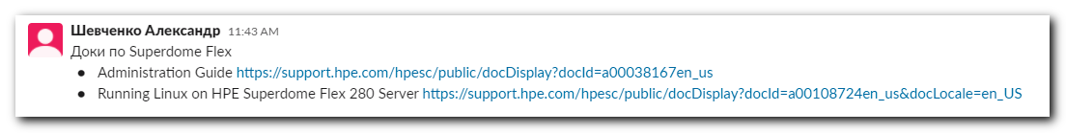
Шевченко Александр 11:43 AM
Доки по Superdome Flex
- Administration Guide https://support.hpe.com/hpesc/public/docDisplay?docId=a00038167en_us
- Running Linux on HPE Superdome Flex 280 Server https://support.hpe.com/hpesc/public/docDisplay?docId=a00108724en_us&docLocale=en_US

